[1]

**Class Navigator**

***Authors:*** Ameya Kherodkar, Chinmay Joshi, Kenneth Okereke, Shivam Mattoo,

*Seidenberg School of Computer Science and Information Systems*

*Pace University, New York, NY, USA*

*Abstract*— Global Position Systems and other navigation systems that collect spatial data through an array of sensors carried on by people and distributed in space have changed the way we navigate complex environments, such as cities. However, indoor navigation without reliable GPS signals relies on wall-mounted antennas, Wi-Fi, or quantum sensors. Despite the gains of such technologies, underlying these navigation systems is the dismissal of the human wayfinding ability based on visual recognition of spatial features. In this paper, we propose a robust and parsimonious approach using Image recognition, Augmented Reality, Deep Convolutional Neural Network (DCNN) to recognize and interpret interior space. In this project we design and develop a pre-zoning indoor space, and from a single phone photo to recognize the learned space features, with no need of additional assistive technology. We collect images and videos inside Pace campus building to train our model and achieve maximum accuracy in validation data set and test dataset based on special-scale fixed model.

*Keywords*— Deep Convolutional Neural Network, Indoor Navigation System, Augmented Reality

# **INTRODUCTION**

Navigating inside the Pace Campus is the problem for students especially the fresher or visitors to find or locate the place thy want to visit. These individuals get confused while locating the places inside the campus as campus is too big to remember all the places. The idea for the Class Navigator application came out of a need for a tool to better manage proper navigation inside Pace campus for fresher, staff members and visitors.

# **Problem Description**

Most of the current technologies for indoor localization and navigation like signal-based and appearance-based approach, mostly rely on hand-crafted features. Their performance highly depend on how efficient the hand-crafted feature extractors are developed and to what context it may apply. In this paper, we propose a method image recognition using Deep Convolutional Network which will interpret and recognize Pace campus interior space and Augmented Reality which will enhance further and show directions within the application which will guide the individual to understand better.

Most of the current technologies for indoor localization and navigation like signal-based and appearance-based approach, mostly rely on hand-crafted features. Their performance highly depend on how efficient the hand-crafted feature extractors are developed and to what context it may apply. In this paper, we propose a method using Augmented Reality(AR) and image recognition to interpret and recognize Pace campus interior space. Compared to the hand-crafted features, DCNN combines a powerful ability in feature learning and deep feature extraction, has been tested to learn the best spatial features automatically, which will be robust and relatively universal to various context. DCNN has achieved outstanding success in object and scene recognition. Actually, the task to recognize object and scene have a lot in common, which are distinguished from each other based on their inherent physical structure and color pattern. However, how good the ability of DCNN to interpret and recognize a segment of space requires more research. Considering the huge spatial variation it may exist along even in 10 meter-wide indoors corridors, an important research aspect is to understand what spatial features DCNN use in order to gain ability in indoor place recognition.

In this study, we proposed a system for robust indoor place recognition using DCNN. In order to test DCNN to recognize location based on spatial features, we focus on a quite bland space: the indoors corridors and space that’s connects several classes. A multi-scale indoor place recognition model is introduced to improve the spatial resolution and accuracy. In the application phase, our system, DeepSpace, takes a single photo picture from cellphone as input , and recognize its corresponding pre-zoned location. The preliminary results on the test data set up error rates of 80& and 90% respectively. A key feature of our approach for pedestrian class navigation is that it does not depend on internet service or special sensors. We focus on photo analysis from common smartphone cameras, and recognize special features of the scene by deep learning and augmented reality which is more parsimonious and robust.

DCNN interprets space based on visual elements, somehow incorporating the human ability of spatial navigation using visual tips. Indeed, assessing the eight state-of-the-art DCNN, used 2D and 3D images, and compared object recognition rates with humans. Based on this important result , which potentially built a connection between DCNN and human cognition, it is also a promising way to understand how human recognize the complex indoor space , by analyzing the spatial features that DCNN learned. Results were promising, showing that DCNN achieved high human-level accuracy when objects are placed against uniform gray backgrounds. However, all those images are outdoors with clearly defined objects outstanding from the background.

# **Literature Review**

Global Positioning Systems (GPS) and other navigation systems that collect spatial data through an array of sensors carried on by people and distributed in space, have changed the way we navigate complex environments, such as cities. As Roger McKinley puts, "the days of being lost should be over". Indoor navigation without reliable GPS signals is a special problem by itself. Whereas satellite-based systems dominate outdoor navigation, indoors navigation will rely on more powerful wall-mounted antennas, Wi-Fi, and quantum sensors, which will give us our position with an accuracy of centimeters. Computer-vision techniques have also been utilized to identify spatial features, such as mobile visual location recognition (MVLR), that recognized a landmark based on query image taken by mobile devices, and find more information about it in similar database images.

# **historical background**

There are many solutions which are available from previously experiment listed below with pros and cons

1. **Using WI-FI strength:** currently the premises are mostly covered with access points to give the internet coverage across the closed area. So, using a finger printing location model was built. Disadvantages of this solutions where it was not compatible for iPhone users and also an extra hardware required.
2. **Using Bluetooth Beacon Receiver:** Every cellphone has Bluetooth technology and using this technology a solution was built where at every destined location a Bluetooth beacon receiver was placed and user will be navigated to the desired location, but disadvantage of this solution was again extra hardware is required and solution was too complex.

# **current solutions**

In the field of indoor navigation, system for users is an example of indoors wayfinding system that uses handheld sign-reader based on an infrared camera to read digital tags distributed in space, using synthetic speech for output to give simple geometrical description. In the field of indoor localization using computer vision, there are basically two approaches to implement localization: Metric SLAM (Simultaneous localization and mapping) based approach and appearance-based approach. Recent work in computer vision has proved that using deep convolutional networks has been an effective approach to perform object detection and scene classification. There is a new research trend on using DCNN models to recognize places. The importance of deep convolutional neural network in support of visual recognition tasks has been well recognized with impressive performance.

Advantage of this solution are as follows:

1. less hardware or no extra hardware installation required.
2. User friendly experience for users using this application as it would be implemented using augmented reality.
3. Maximum Accuracy: Since we would be using the user’s phone camera and Deep Convolution Neural Network, hence the accuracy would be high.

# **Comparison between different indoor navigation systems**

| **Name** | **Accuracy** | **Infrastructure** | **Maintenance** | **Power Source** | **Other** |
| --- | --- | --- | --- | --- | --- |
| WIFI Triangulation | 5 − 30 m | Usually existing | Remapping | Device battery + AC | Relies on existing infrastructure |
| Bluetooth Beacons | 2 − 30 m | Hardware installation, Device management | Remapping | Device battery + AC |  |
| Magnetic Field Measurement | 2 m | API + initial magnetic mapping | Crowdsourced | Device battery |  |
| Pedestrian Dead Reckoning | Varies | None | Crowdsourced | Device battery | No additional devices / services needed |
| Point-cloud from Images | 5 m | API + initial photoshoot | Crowdsourced | Device battery | Creates 3D model to be used with AR etc. |

# **Project Requirements**

Our mission is to design and develop a cross-platform mobile application for Pace university that addresses indoor space navigation issues inside Pace campus. Our aim is to develop an application that assists fresher or school faculties with indoor navigation which will provide elegant, aesthetically pleasing panoramic tour to Pace Campus.

In general, class Navigator will function like Global Position System and hence should have several key requirements that can be modeled directly from current solutions:

1. **User Management:** Every individual should be logged in with his pace credentials in order to access this application. Only registered users can would be able to access this application due to the security restriction.

2. **Search Bar:** Once you are logged in into the application you should have a search bar where user can enter the destination location and start the navigation

3. **Tour Guide:** Once Navigation is started a user-friendly guiding system should be available for the ease of the user. So, we choose to go with the latest technology called as Augmented Reality(AR) which is an interactive way of guiding the user to their desired location.

*Programming languages:*

1. Java 8: Implementation of class navigator backend is coded using Java 8 for android app
2. SWIFT language is used to get image of the current location for IOS app
3. The model is trained using DCNN model and Augmented reality is used to perform object detection.

​*Application development languages and Softwares:*

1. Android Studio/Ionic Framework: The mobile application is developed using Android Studio/Ionic Framework.

*Database:*

Firebase is used for the data storage as a database where we have stored all the trained images for the class navigator

# **Architecture**

Our implementation of the class navigator application follows a standard client-server architecture. Technologies which will be used at both the ends are as follows:

1. Client – Mostly at the client side since the machine which would be used to use this application would be the cell phones, and till date two major operating systems i.e. Android and IOS are available we would be using phones camera and JAVA and SWIFT language to get image of the current location and code our client application front end respectively. Also, we would be using python and AR CORE library for augmented reality(AR) implementation.

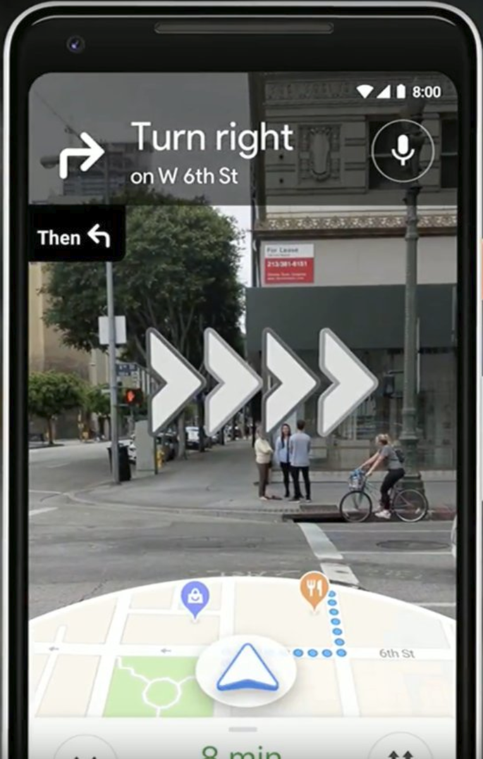

*Figure 1: Show how the user experience would be on the client application where user is guided using interactive directions using Augmented Reality(AR).*

1. Server – This is the place where client will connect, and major operations would be performed. So here we would be running python at the backend and MongoDB / Hadoop NOSQL database to store the large image dataset which would be derived from video’s we would be capturing from the GoPro action camera which will give us more stable video resulting in good image dataset. Now using this image dataset, we will train our model which we will be creating using Deep Convolutional Neural Network(DCNN).
2. Deep Space System-

In this section, we introduce the DeepSpace system framework. The proposed formulate the indoor localization as a discriminative classification task : Given one image taken from concerned area, we train a classifier that could predict its corresponding pre-zoned segment.

Figure shows the DeepSpace system framework. In the training phase, we use data extracted from video to train two spatial-scale DCNN models. The first model used data labeled in building-level, which localize the input image to a building segment. The second model is trained with room-level data, aiming at recognizing sub-segment inside one building segment. In service phase, the building-level DCNN model will first predict its building-level segment coarsely, and send to corresponding room-level DCNN model based on its prediction, for high-precision localization.

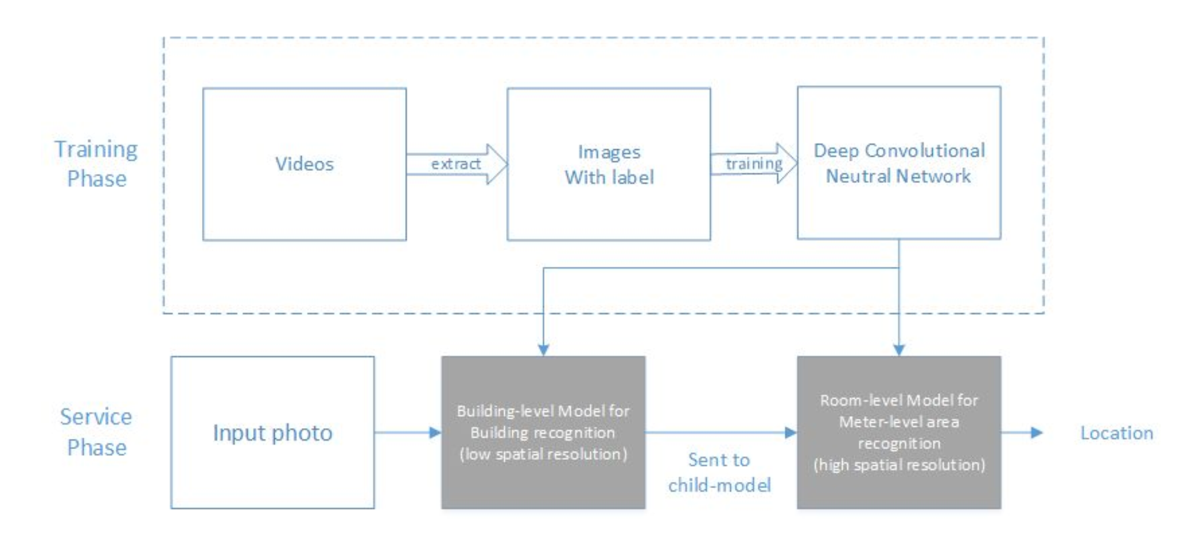

*Figure 2: In the training phase, DCNN model is trained with images derived from the video. In service phase the building-level DCNN model will first predict its building-level segment and send to room-level DCNN model based on its prediction.*

1. Data Collection:

The corridors also serves as the most direct indoor route within the campus. However , people new to Pace , being students or visitors, usually have difficulty in finding their way when navigating the campus through its hallways.

We took the videos using normal cellphone camera for more stability with clear and high definition video data. Considering the intensity variance of ambient light and the distribution of crowds, we collected several sets of data in different times of the day. The device was hand held to keep the camera’s shooting angle at human level. We also tried to cover wide range of view angles in each position, in order to produce a detailed and complete descriptive dataset of indoor spaces.

The images for DCNN training were extracted from videos. The whole procedure includes five steps: 1) Video fisheye distortion correction for all videos, and convert video format to 480p@30fps. This was implemented using GoPro Studio software; 2) Extract images from all frames of the video and rescale to 256×256; 3) Remove low quality images with blur indicator less than 0.45. Here we implement the detecting algorithm; 4) Randomly split the dataset into two: 300 images from each category as validation dataset, and use the rest as training dataset; Then we have labeled the images and mapped them according to the direction of space within the campus. The image amount varies from categories, which is consisted within the area and complexity of target segment.

**Path 1:**

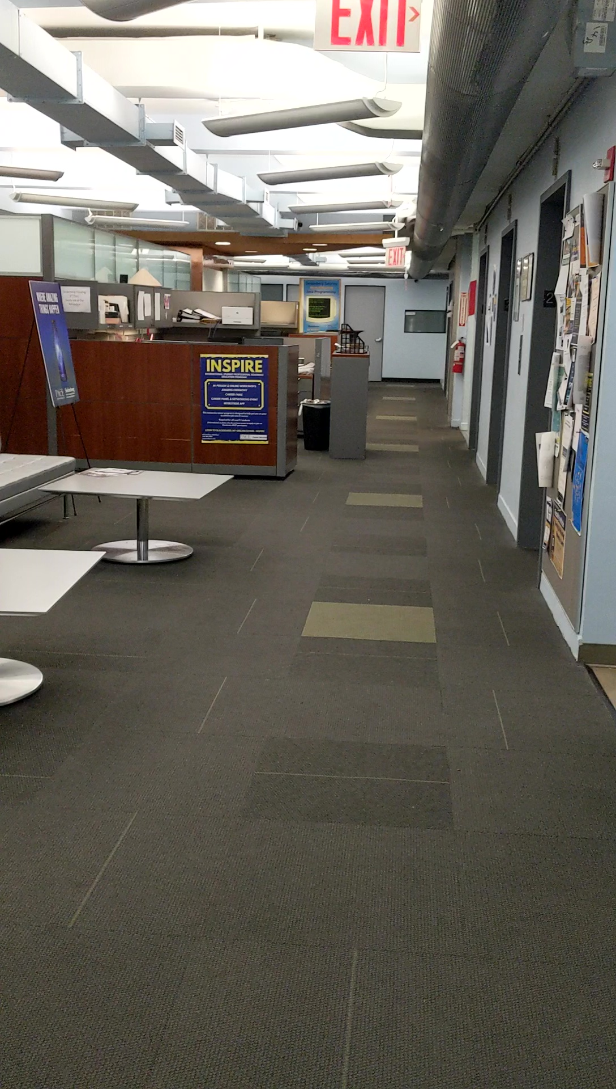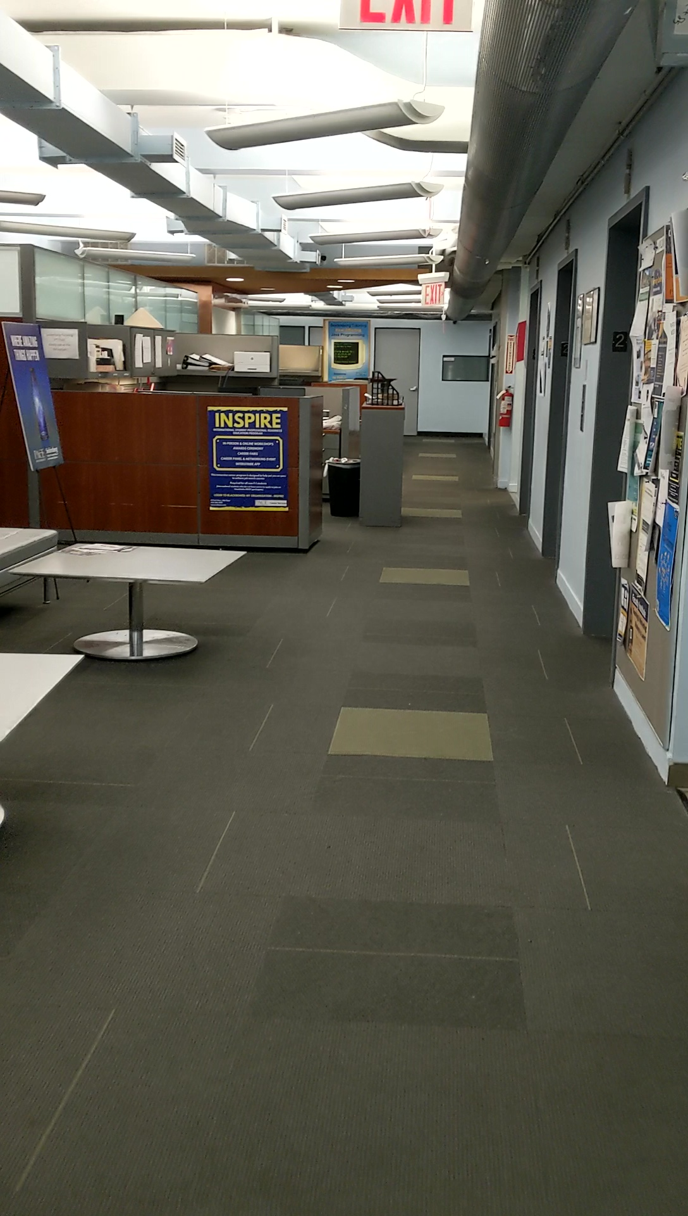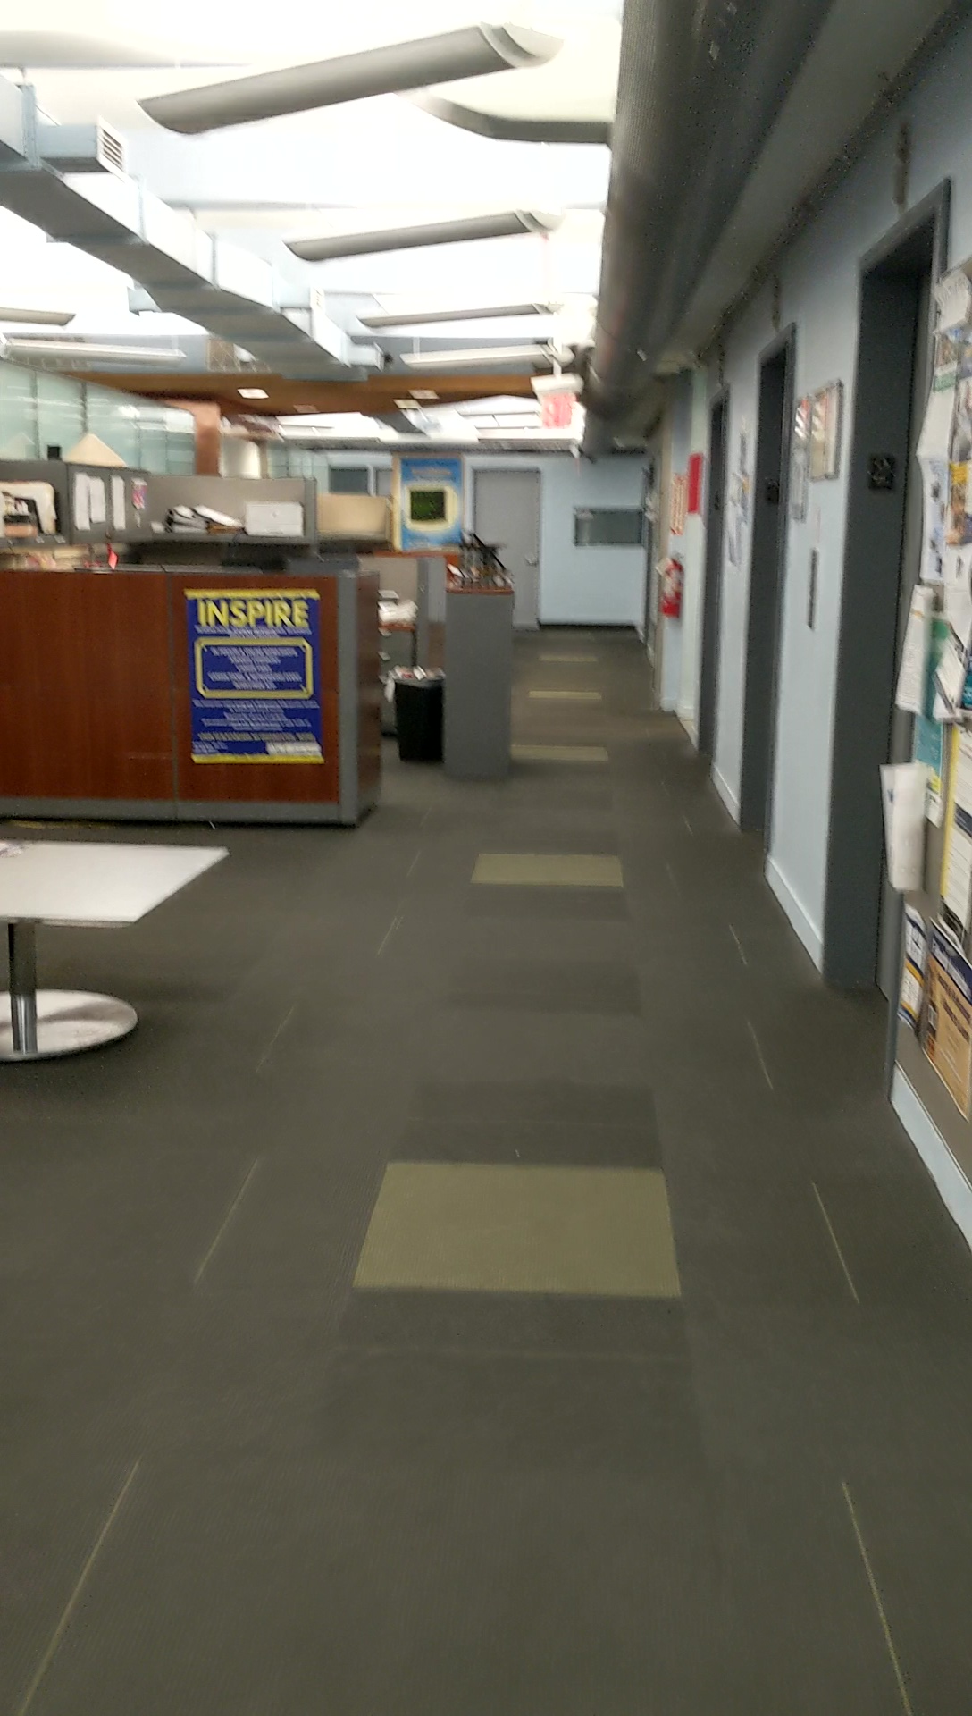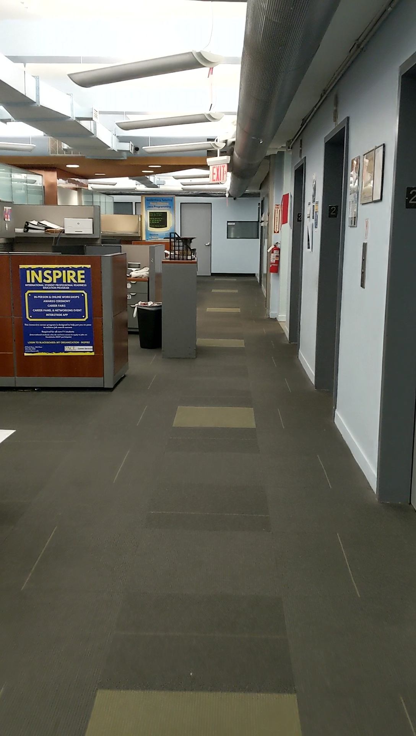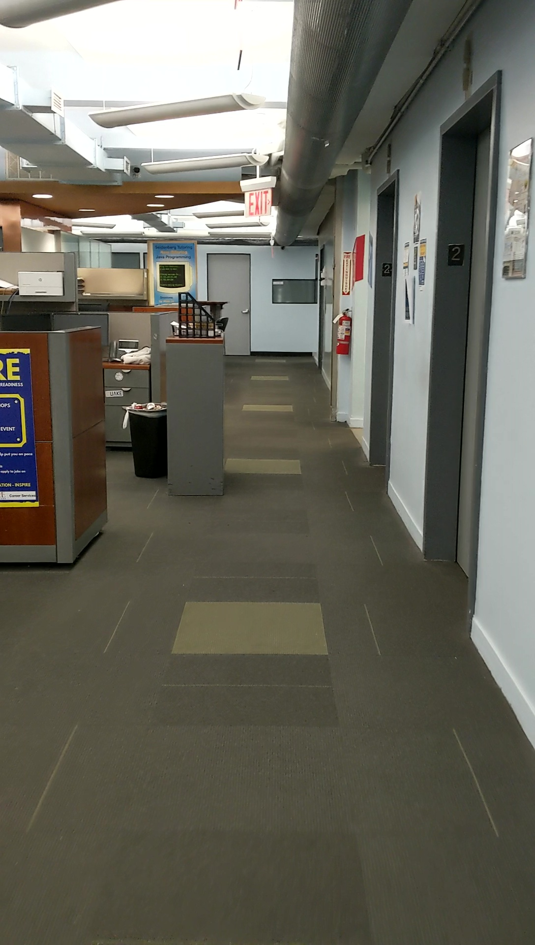

**Path 2:**

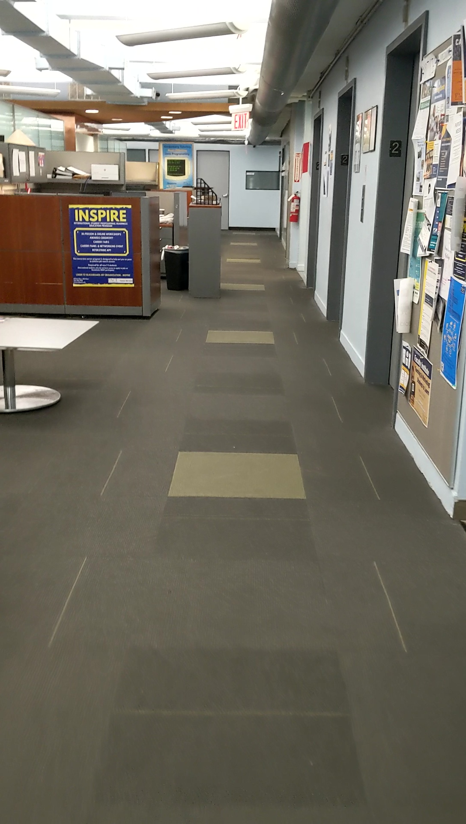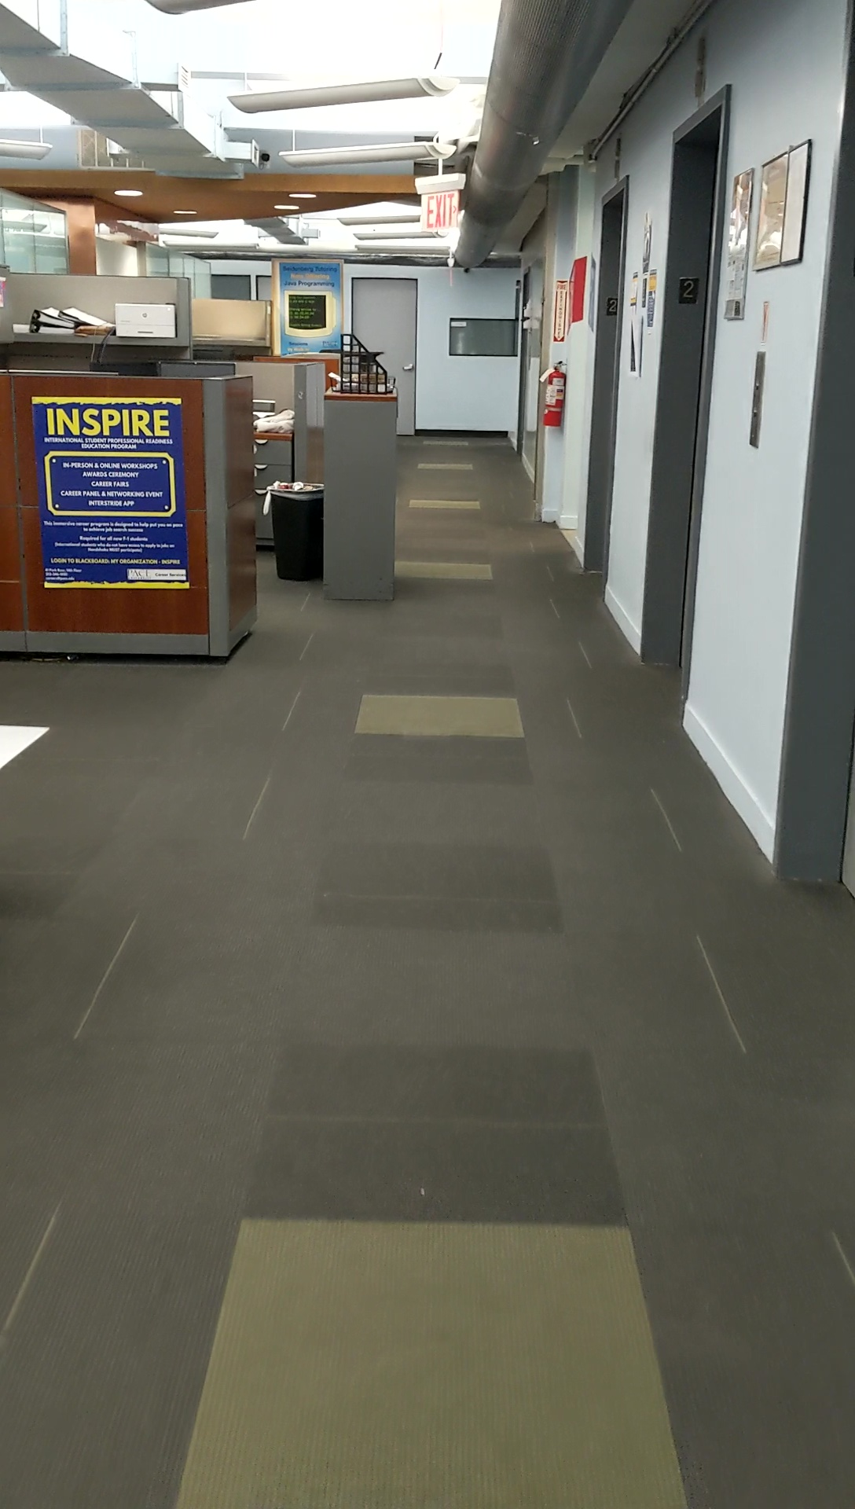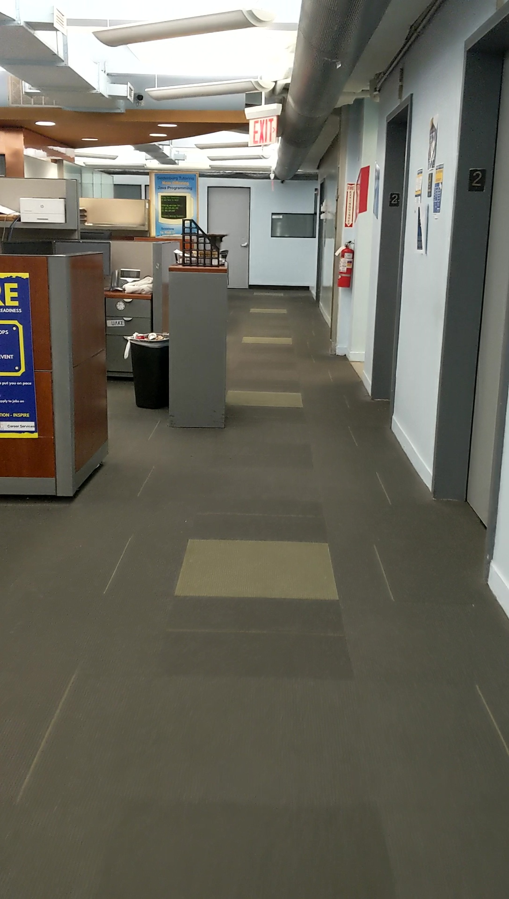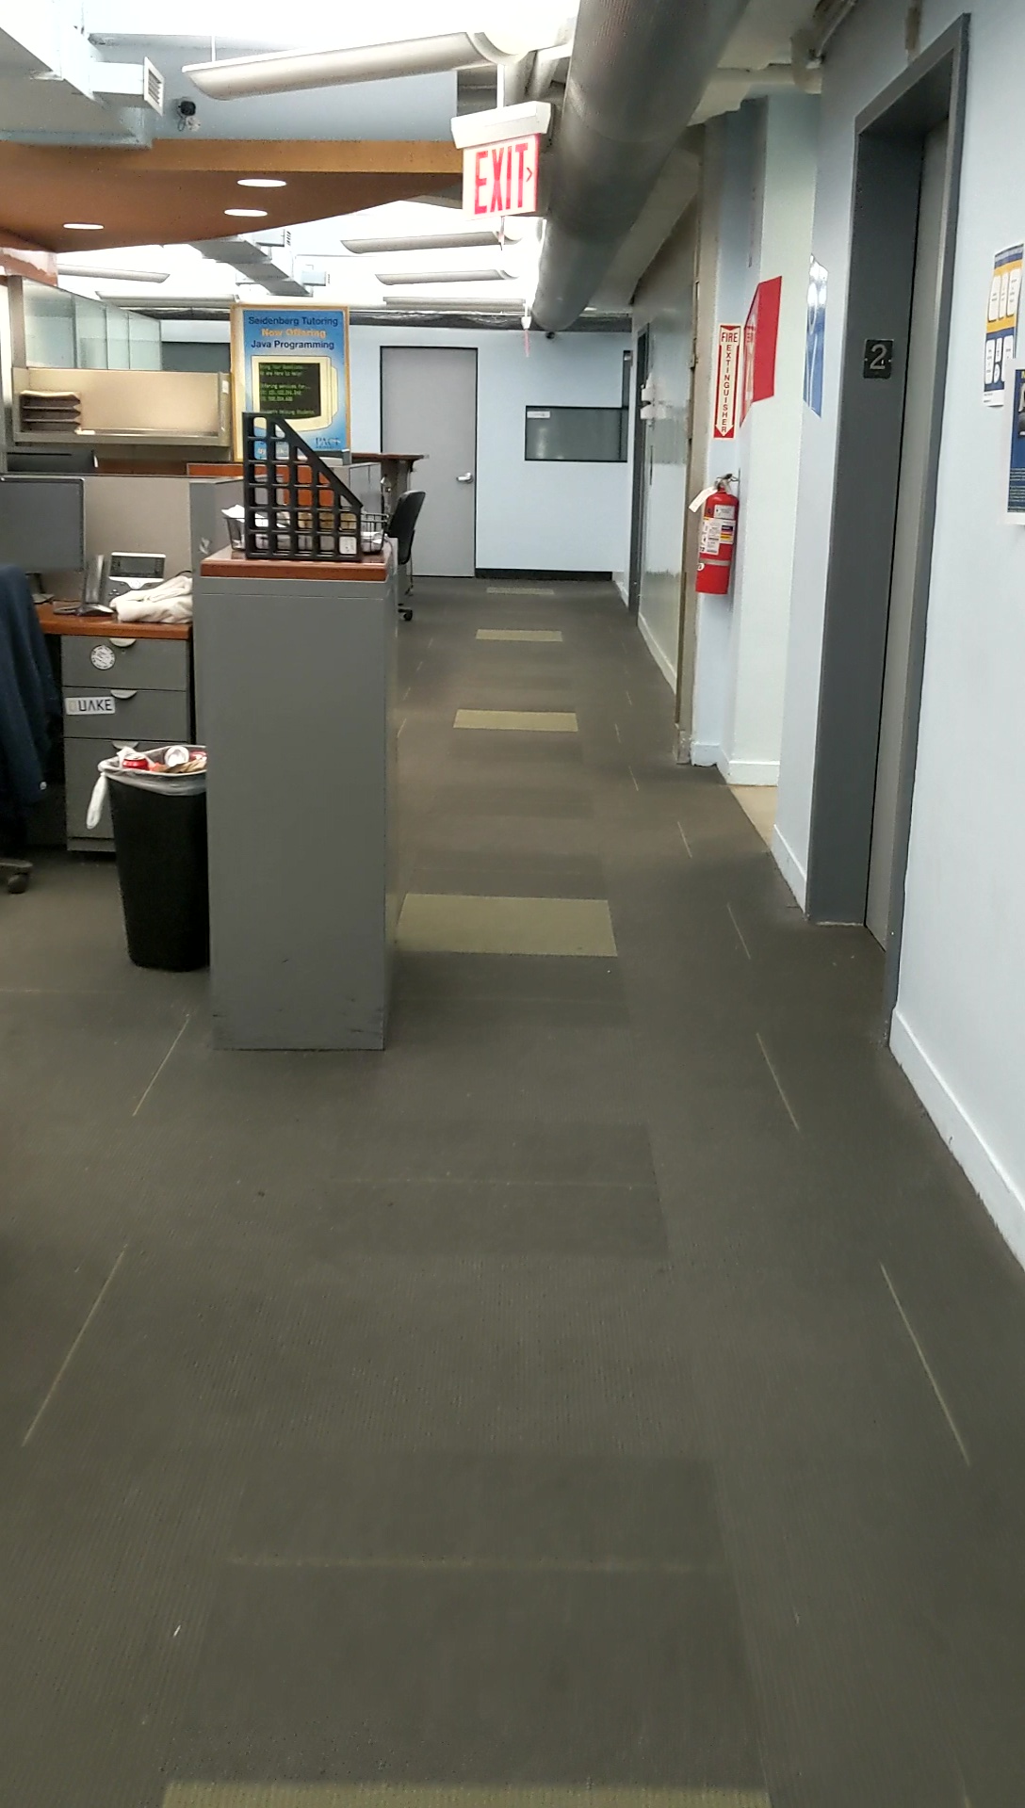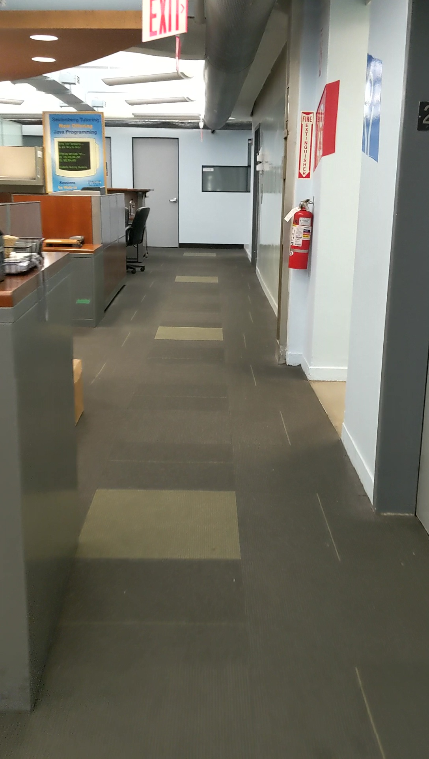

**Path 3:**

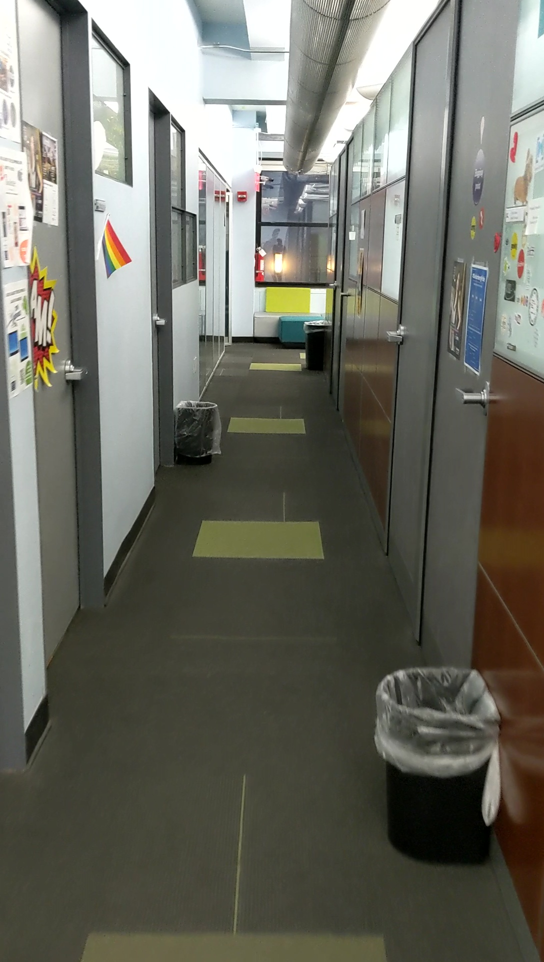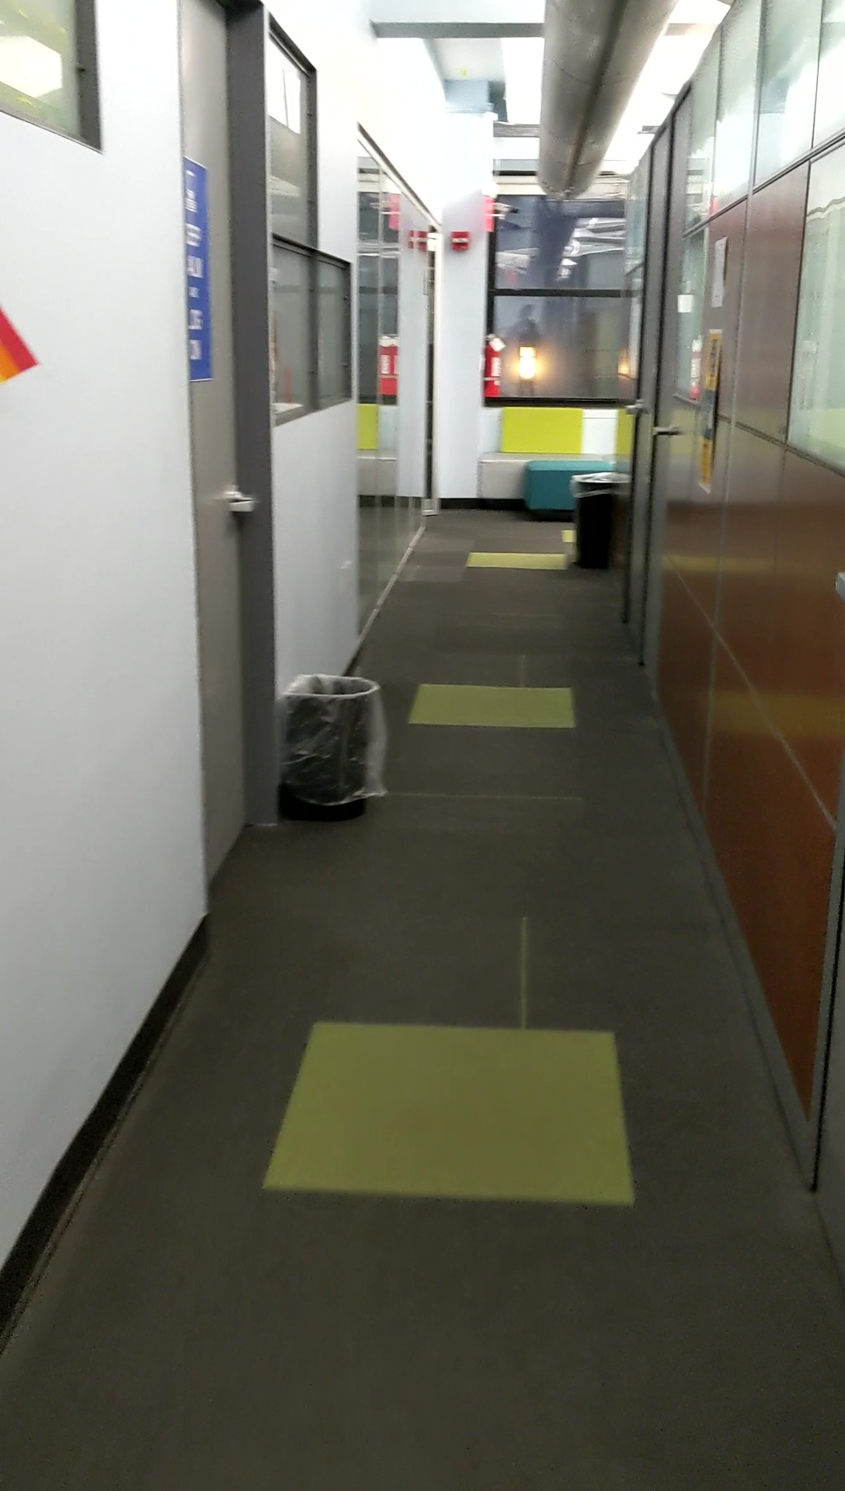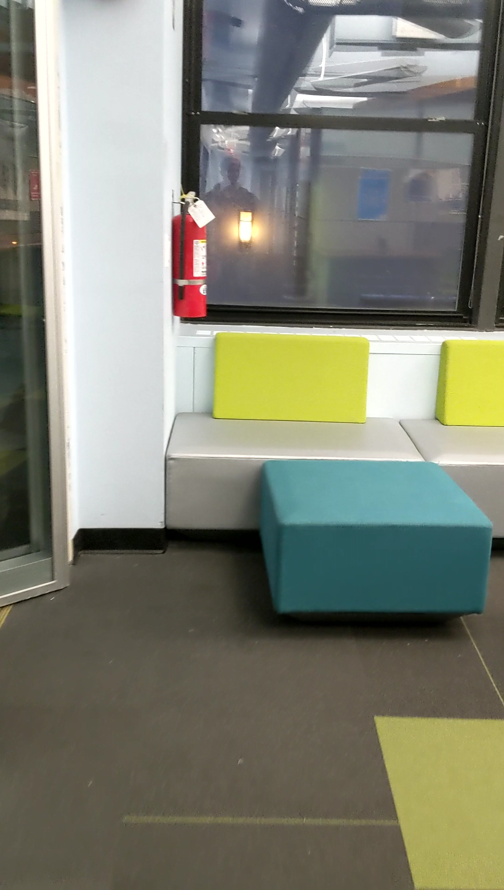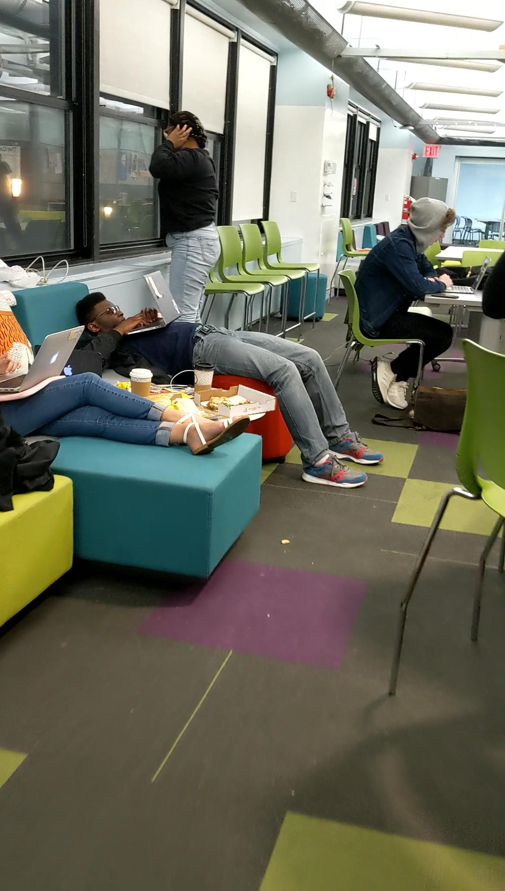

*Figures shows the example of training dataset*

1. Security, Storage and Accessibility

Three basic principles of any mobile application or software is its security, storage and accessibility. These principles can be achieved efficiently using affordable cloud services. We will be using AWS cloud services to make our application more secure, have unlimited storage and accessible all over the world using the internet. We will be using the following services for our application

* AWS Amplify (Mobile Services)
* Mobile Hub (Mobile Services)
* AWS AppSync (Cloud integration)
* Cloud Watch (Monitoring)
* DynamoDB (Backend)
* Pinpoint (Analytics)
* IAM (Security)
* Cognito (Security)
* AWS Lambda (Serverless backend)



Figure 3: AWS cloud services for Security, Storage and Accessibility of Mobile applications.

# **Class Navigator Design**

Our approach is to provide cross platform application based on android and iOS where we have mobile app to provide navigation using search option the app. Front end is developed using java and swift to provide user interface. Below are few images of mobile application.

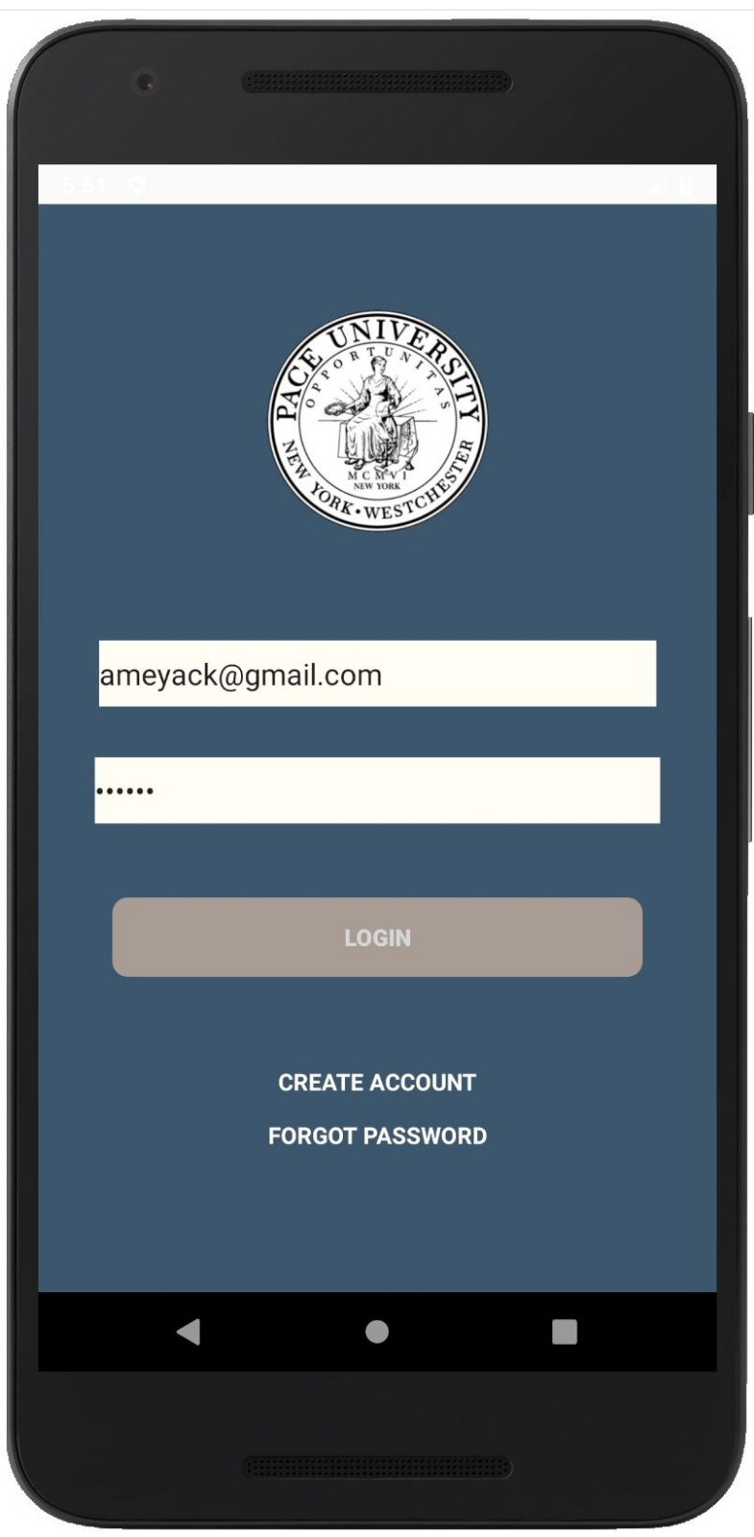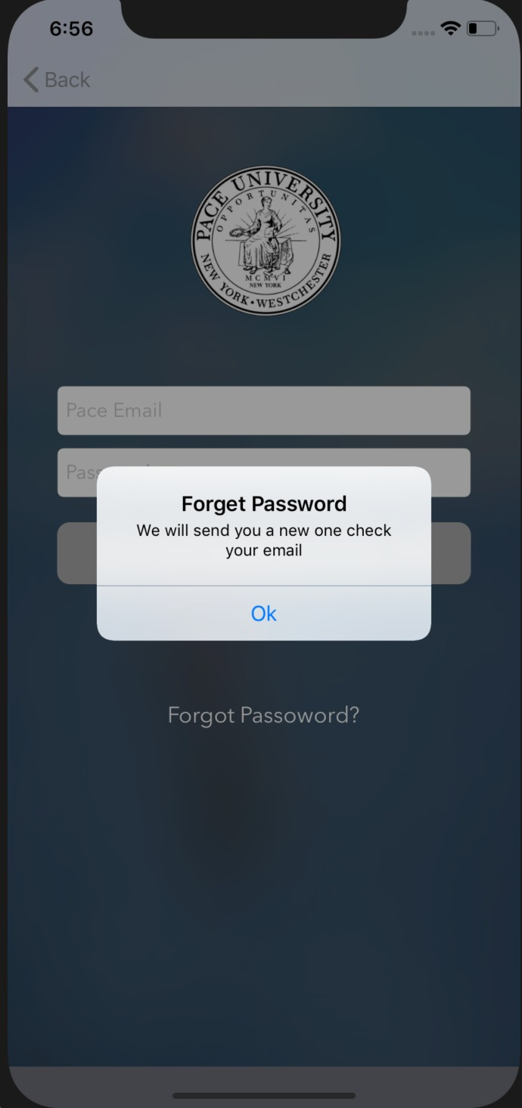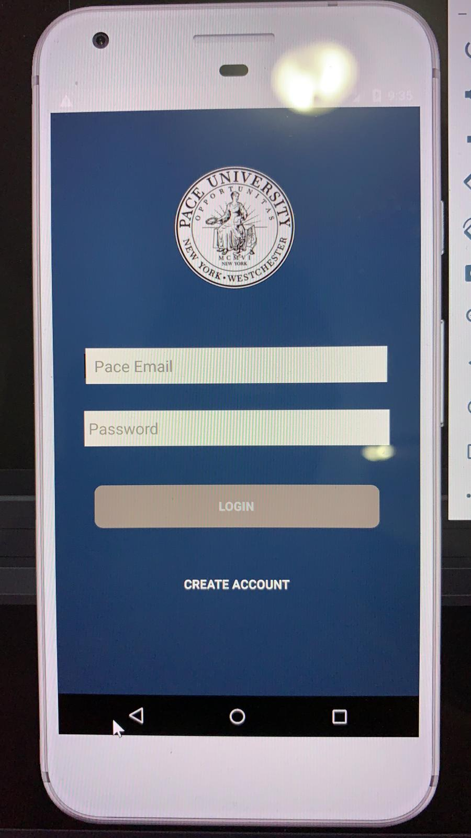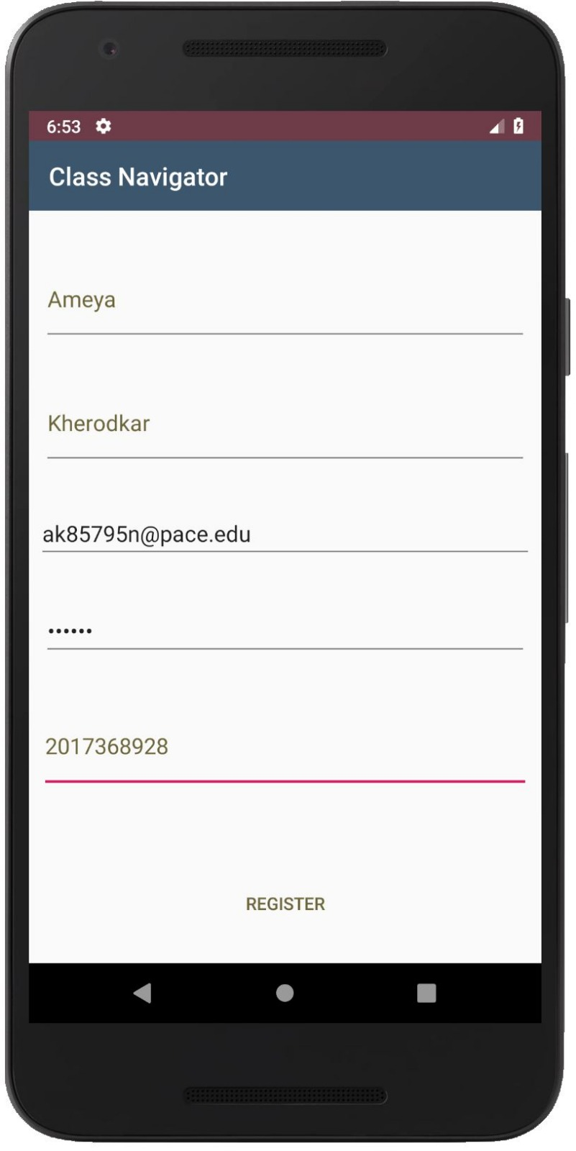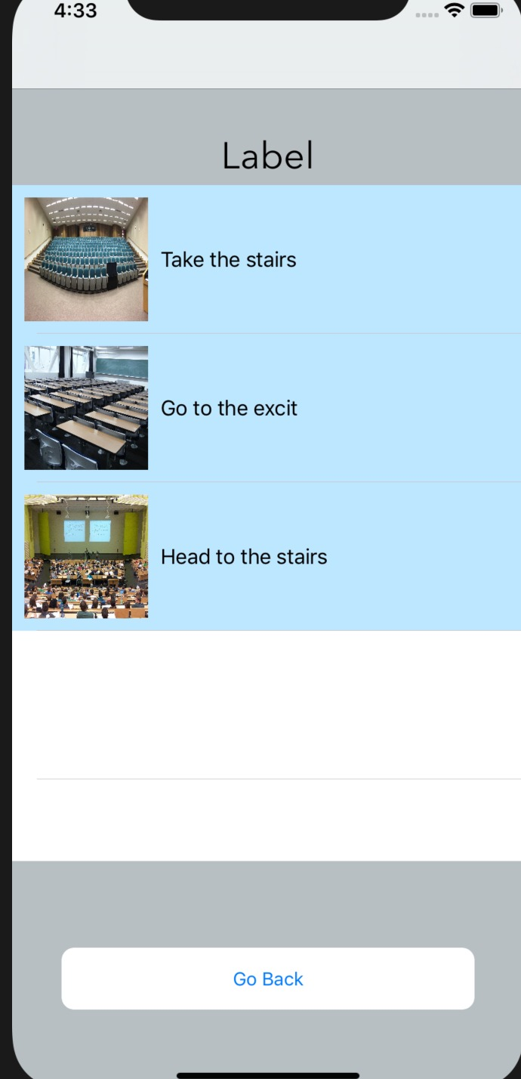

# **Discussion and future work**

Both outdoor and individual navigation technologies have become increasingly accurate, either relying on GPS coverage, or Wi-Fi and other communication technologies. However, in this process the key human feature of navigating space based on spatial recognition based on visual cues, is not taken into account. More recently, computer vision, machine learning and other more advanced techniques have been tested to taken into account visual features as a way of identifying particular spaces, and increment spatial navigation.

In this paper we introduced a robust and parsimonious indoor place recognition method using a DCNN model, which achieved good results in a case study realized at PACE campus. We present a multiscale hierarchical model to improve the resolution and accuracy of localization. The model is parsimonious without having the aid of vision or signal based handcrafted features, and the method could be adapted to various scenarios. The result show that DCNN model has the ability to interpret the space in a comprehensive way and recognize interior space with high accuracy, which could be applied to indoor localization and navigation.

From a modeling perspective, the DCNN model learns the inherent features that distinguish the indoor space with one another, providing insight to study of inferior space, to design a more targeted DCNN architecture which could perform better in large-scale indoor localization. Future works will continue to focus on analyzing the deep features that DCNN learns, understanding model’s behavior in decision process, and somehow comparing with human’s indoor perception and wayfind ability. By understanding the relationship between spatial features and confusion degree, the long term significance of future works aims to bring insights in how to conduct architectural design using friendlier approaches, from the perspective of human cognitive architecture, enhancing people’s recognition of spatial features and navigation in indoor environments.

# **Conclusion**

## The author of this paper has implemented class navigator as an application which addresses some of the lacking features of the Global Position System(GPS) and have addressed a solution to overcome this problem.

# **REFERENCES**

# 

[1] Sterling, Greg (Opus Research, I.. (2014). Magnetic Positioning, 1–8.

[2] Zandbergen, P. A. (2009). Accuracy of iPhone locations: A comparison of assisted GPS, WIFI and cellular positioning. Transactions in GIS, 13(SUPPL. 1), 5–25. http://doi.org/10.1111/j.1467-9671.2009.01152.x

[3] Bekkelien, A. (2012). Bluetooth indoor positioning. Master’s Thesis, University …, (March), 1. Retrieved from http://cui.unige.ch/~deriazm/masters/bekkelien/Bekkelien_Master_Thesis.pdf

[4] Beauregard, S., & Haas, H. (2006). Pedestrian dead reckoning: A basis for personal positioning. Positioning, Navigation and Communication, 27–35. http://doi.org/10.1613/jair.301

[5] Liu, H., Darabi, H., Banerjee, P., & Liu, J. (2007). Survey of wireless indoor positioning techniques and systems. IEEE Transactions on Systems, Man and Cybernetics Part C: Applications and Reviews, 37(6), 1067–1080. http://doi.org/10.1109/TSMCC.2007.905750

Posted by Jaan Tollander de Balsch 2016-10-28   misc.

1.